Lab - 02

LAB # 02: INTRODUCTION TO PACKET TRACER
1. PACKET TRACER

Packet tracer is an alternate of boson network simulator here you can create network just like you do in boson network simulator the difference is that it also gives you pictorial view of the device with its panels and interfaces. You can also send variety of packets and see them travel from one node to another along with that telling which layers are involved on the way. This is an application that gives you interactive environment un-like any other.

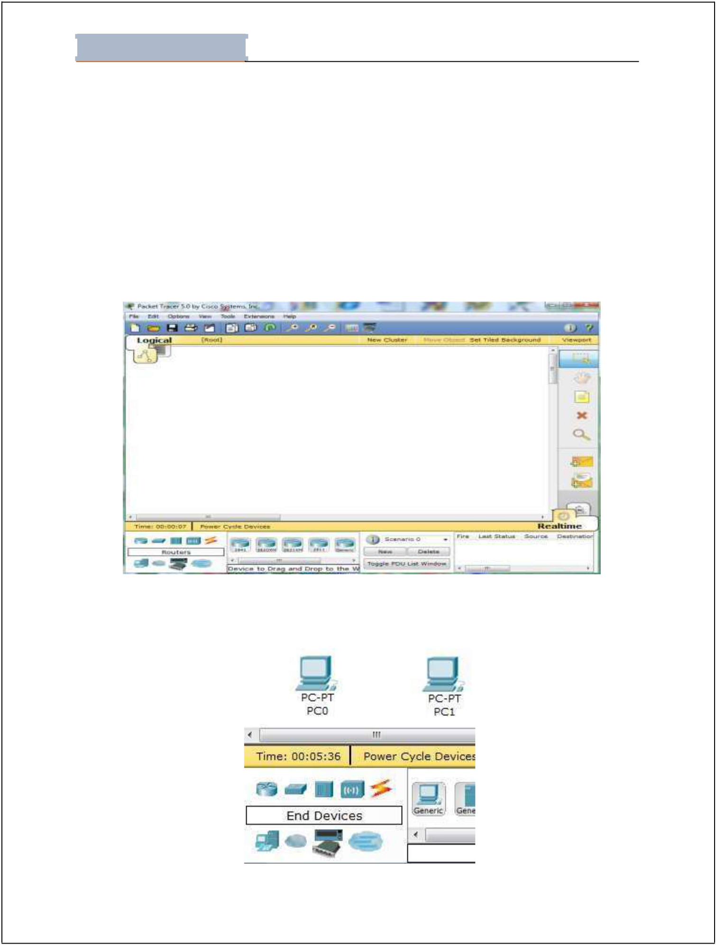
Lab - 02

Student Name: ________________________________Roll No: __________________ Section:__________

2.1. PACKET TRACER MODES

Cisco Packet Tracer provides two operating modes to visualize the behavior of a network — real-time mode and simulation mode. In real-time mode the network behaves as real devices do, with immediate real-time response for all network activities. The real-time mode gives students a viable alternative to real equipment and allows them to gain configuration practice before working with real equipment.

In simulation mode the user can see and control time intervals, the inner workings of data transfer, and the propagation of data across a network. This helps students understand the fundamental concepts behind network operations. A solid understanding of network fundamentals can help accelerate learning about related concepts.

Figure 13. Packet Tracer

At the bottom there is a list of devices which you can select.

Drag n drop devices on to the main working area.

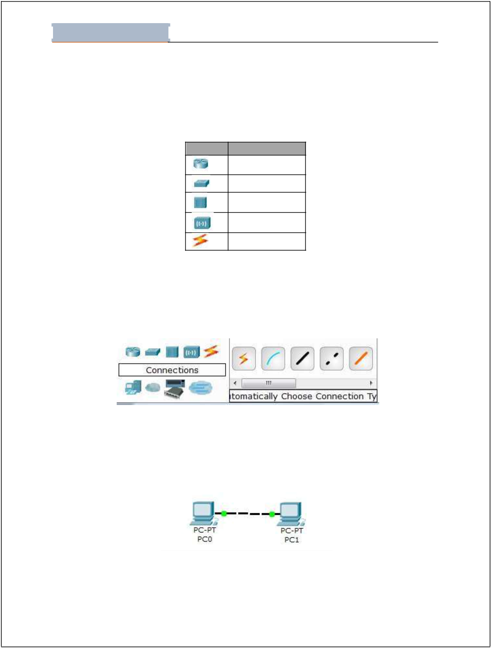
Lab - 02

Student Name: ________________________________Roll No: __________________ Section:__________

Figure 14. Select and Place Devices

Above screen shows two PCs selected for interconnection.

List of some of the icons are shown below:

Symbol Device Name

Router

Switch

Hub

Wireless Device

Connections

Figure 15. Device Details

Press the right most icons this icon is of “Connections” you will see different options like straight, cross-over or fiber if you don’t know the type of connection that will be used then simply select “Automatically Choose connection type” this will be the first option you will see after selecting “connections”.

Figure 16. Connections

Between similar devices if connection needs to be done then type of wire used is “Coppe r Cross Over”.

Select type of wire using mouse and click on PC0 then Click it again on PC1 your connection will establish.

Figure 17. Connect PCs
Click PC0.

A screen will open.

Look at the top of this screen and you will see three tabs

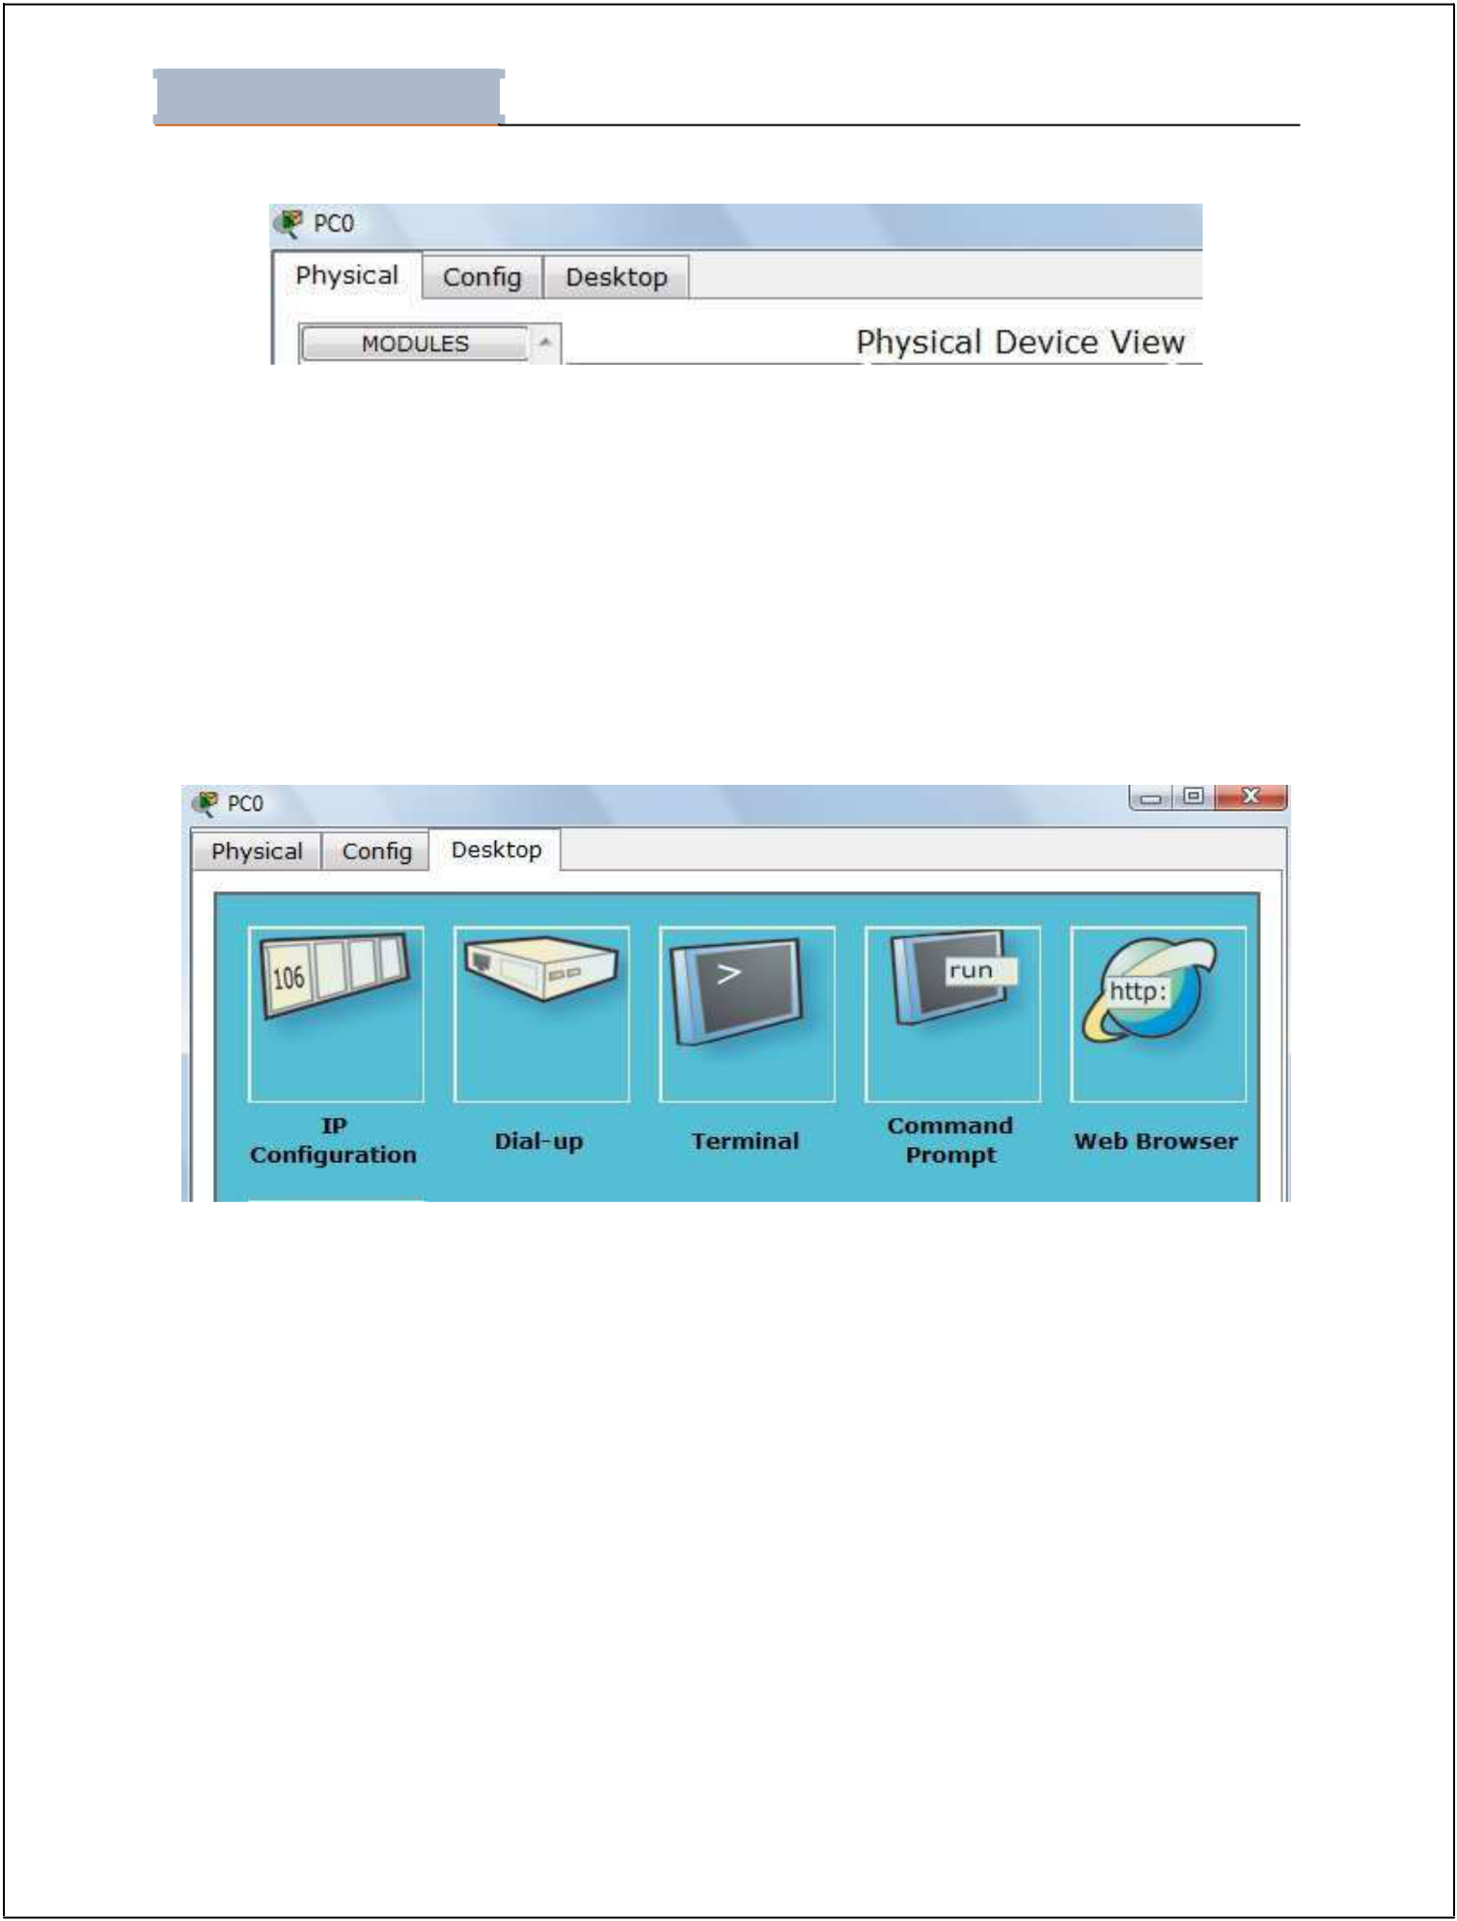
Lab - 02

Student Name: ________________________________Roll No: __________________ Section:__________

Figure 18 Physical Device View

Physical, Config, Desktop.

Click Desktop

Now click Command Prompt.

At command prompt type “ipconfig” to see IP address of PC

If all fields are Null then exit this window and go to “IP Configuration” Tab shown below

Figure 19. Accessing PC Desktop

Click IP Configuration.

Enter IP 192.168.1.1 and select “static”

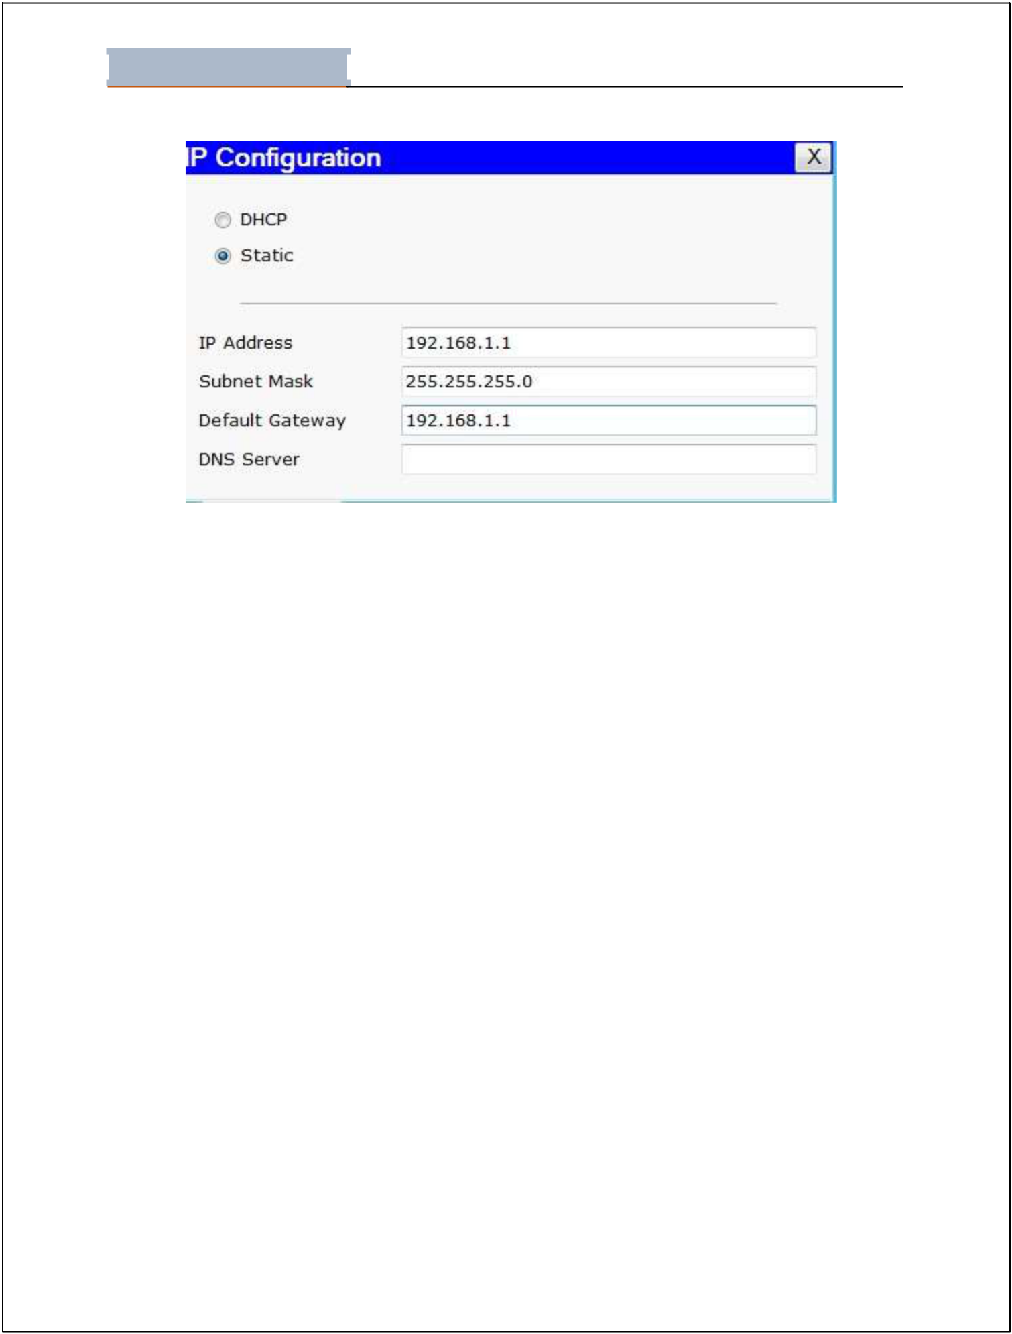
Lab - 02

Student Name: ________________________________Roll No: __________________ Section:__________

Figure 20. IP Configuration

Do the same for PC1.

Set IP and Default Gateway 192.168.1.2

Now use PING command to check connection.

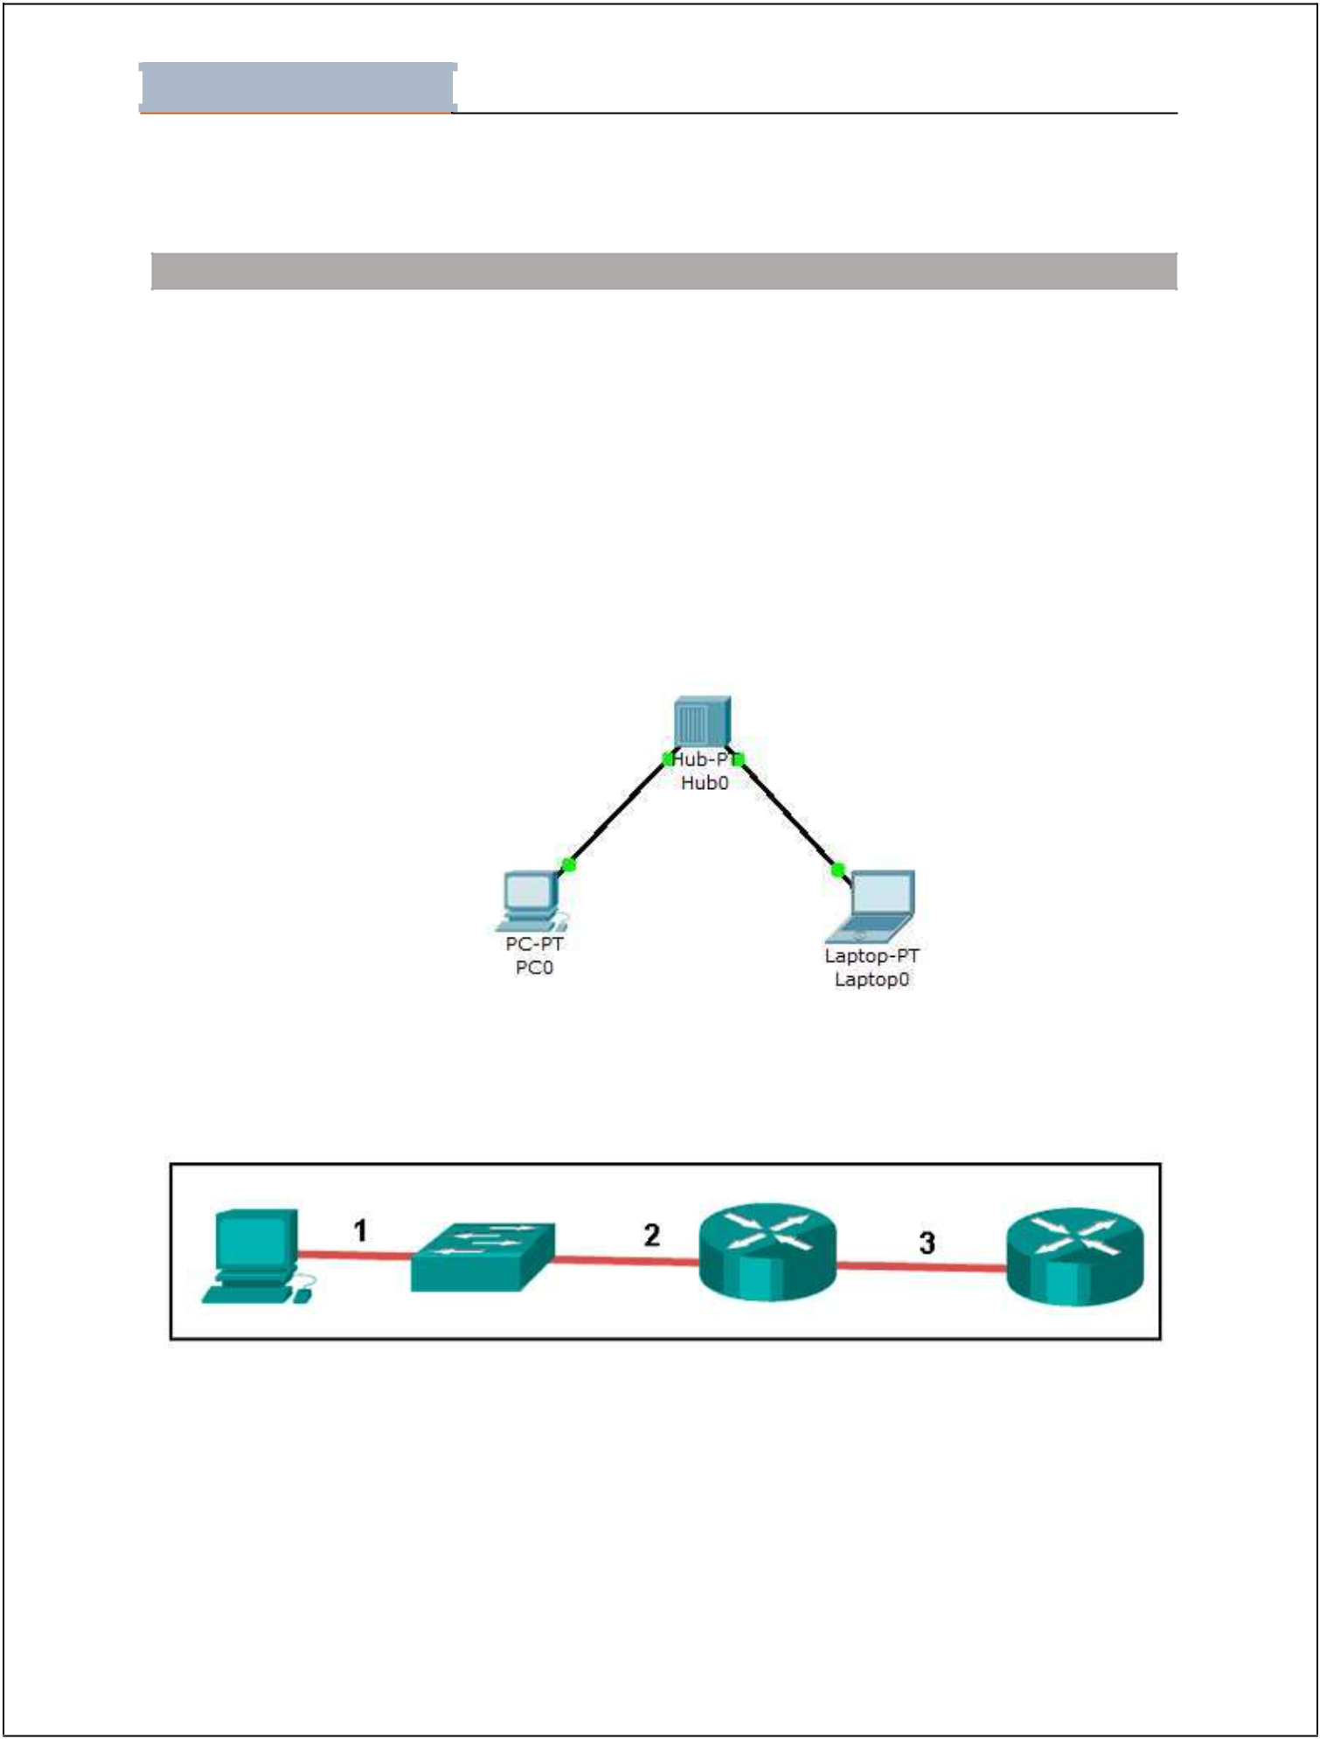
Lab - 02

Student Name: ________________________________Roll No: __________________ Section:__________

Lab Tasks

- Take two PCs, connect them with suitable wire and also describe the reason of selection of wire. Assign them IP addresses and check their connectivity by using PING command. (Use Packet tracer for this task).

PC 0 IP Address Screenshots:
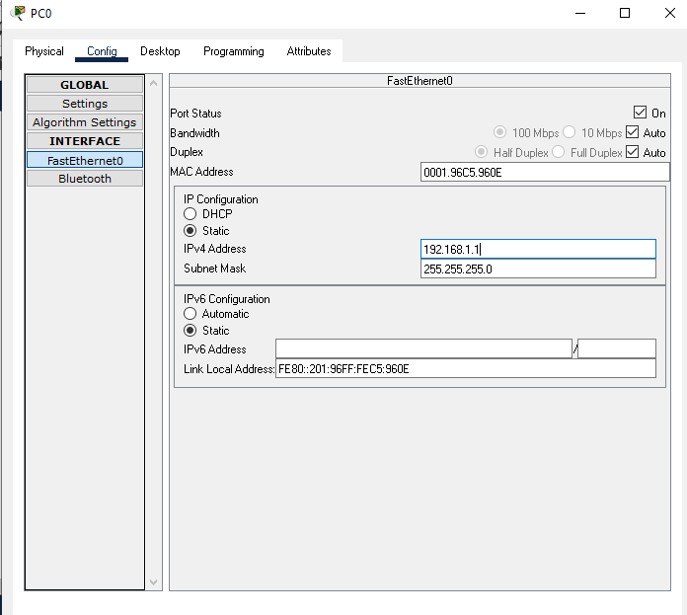

PC 2 IP Adress:

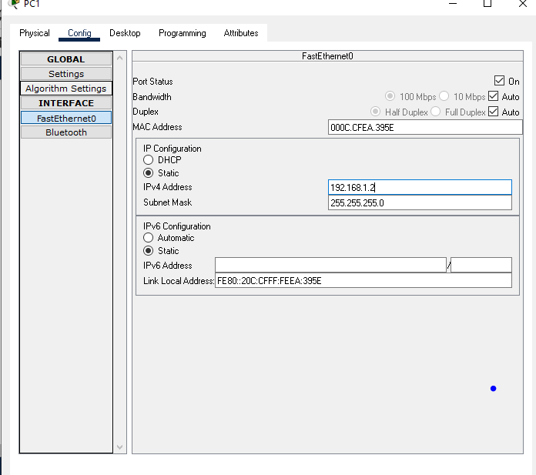

Wire:
In this scenerio the wire which I used is “Copper Cross Over” the reason behined it because both th Pc’s are same and If the objects are same then Copper cross over wire is used.

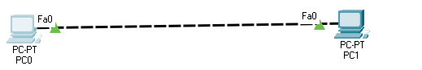

PING Command:
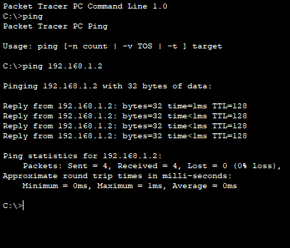

Design and configure the network given in the figure below and check the connectivity by PING command. Also describe the functionality of HUB device in given scenario.

Packet Tracer PC Command Line 1.0
C:\>ping 192.168.1.2

Pinging 192.168.1.2 with 32 bytes of data:

Reply from 192.168.1.2: bytes=32 time=15ms TTL=128
Reply from 192.168.1.2: bytes=32 time<1ms TTL=128
Reply from 192.168.1.2: bytes=32 time<1ms TTL=128
Reply from 192.168.1.2: bytes=32 time<1ms TTL=128

Ping statistics for 192.168.1.2:
Packets: Sent = 4, Received = 4, Lost = 0 (0% loss),
Approximate round trip times in milli-seconds:
Minimum = 0ms, Maximum = 15ms, Average = 3ms

Functionality of HUB:

Basically, Hub is central connection point for local area LAN. When the HUB receives a packet at its one port, so it distributed to all other ports. it is not an intelligent device.

- Consider the following figure. The PC is connected to the console port of the switch. All the other connections are made through Fast Ethernet links. Which types of UTP cables can be used with segment 1, 2 and 3?

Answer:
A straight-through cable is commonly used to interconnect a host to a switch and a switch to a router. A crossover cable is used to interconnect similar devices together like switch to a switch, a host to a host, or a router to a router. If a switch has the MDIX capability, a crossover could be used to connect the switch to the router; however, that option is not available. A rollover cable is used to connect to a router or switch console port.

- What is the significance of Real-time mode and logical mode in packet tracer? Describe briefly?
Answer:
Real time Mode:
In real-time mode the network behaves as real devices do, with immediate real-time response for all network activities. The real-time mode gives students a viable alternative to real equipment and allows them to gain configuration practice before working with real equipment.

Simulation Mode:
In simulation mode the user can see and control time intervals, the inner workings of data transfer, and the propagation of data across a network. This helps students understand the fundamental concepts behind network operations. A solid understanding of network fundamentals can help accelerate learning about related concepts.

